Practical 11
1. Aim
To configure Hyper-V on Windows 11 Pro and create a virtual machine using Hyper-V Manager.
2. Requirements
- Computer or laptop with Windows 11 Pro.
- Minimum 4 GB RAM (8 GB or more recommended).
- 64-bit processor with Intel VT-x or AMD-V virtualization support.
- Hardware virtualization enabled in BIOS/UEFI.
- Sufficient free disk space.
- Windows 11 Pro operating system.
3. Theory
Hyper-V is a virtualization technology developed by Microsoft that allows users to create and run multiple virtual machines on a single physical computer.
A Virtual Machine (VM) is a software-based computer that runs its own operating system and applications independently of the host computer.
Hyper-V allows users to:
- Create and manage virtual machines.
- Run multiple operating systems on one computer.
- Allocate RAM, CPU, and storage to virtual machines.
- Create virtual networks.
- Test software in an isolated environment.
4. Procedure
Step 1: Check System Requirements
- Open the Start menu.
- Search for System Information.

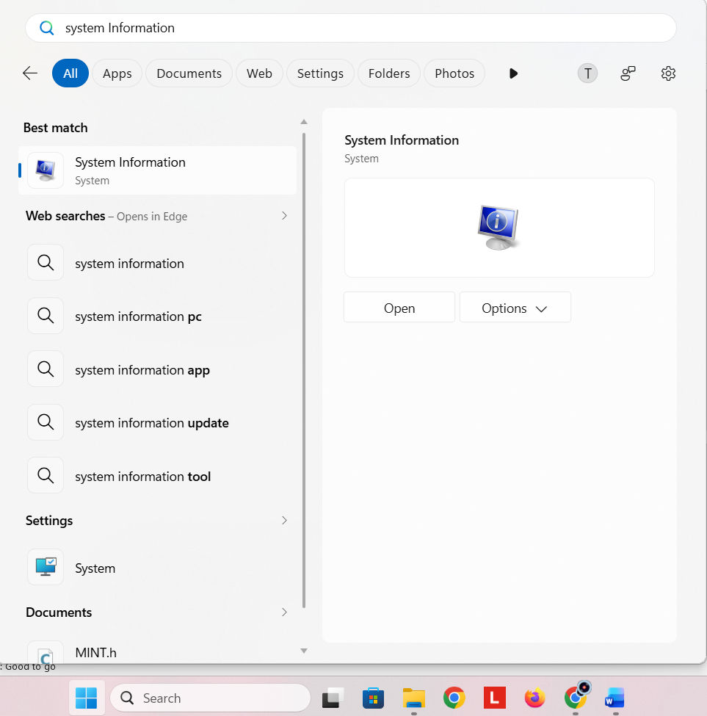
- Open System Information.
- Check that the system supports virtualization.

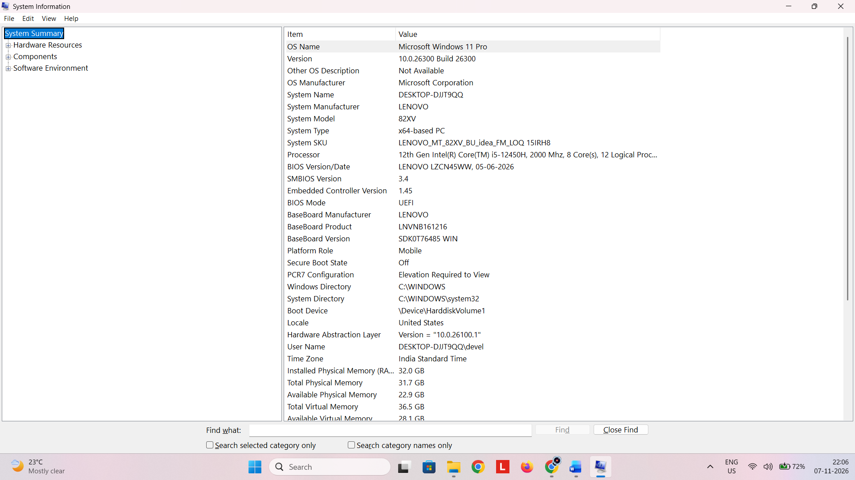
- Ensure virtualization is enabled in BIOS/UEFI from Task Manager.

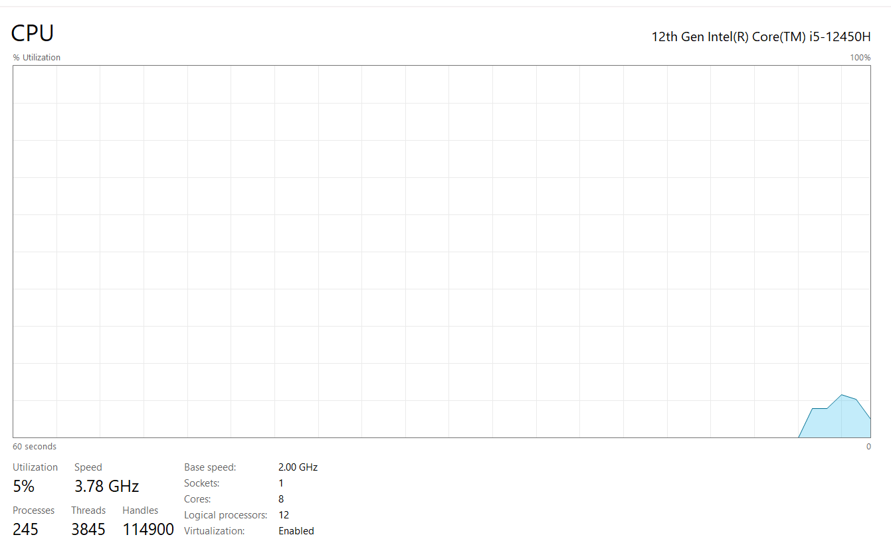
Step 2: Enable Hyper-V
- Open the Start menu.
- Search for Turn Windows features on or off.

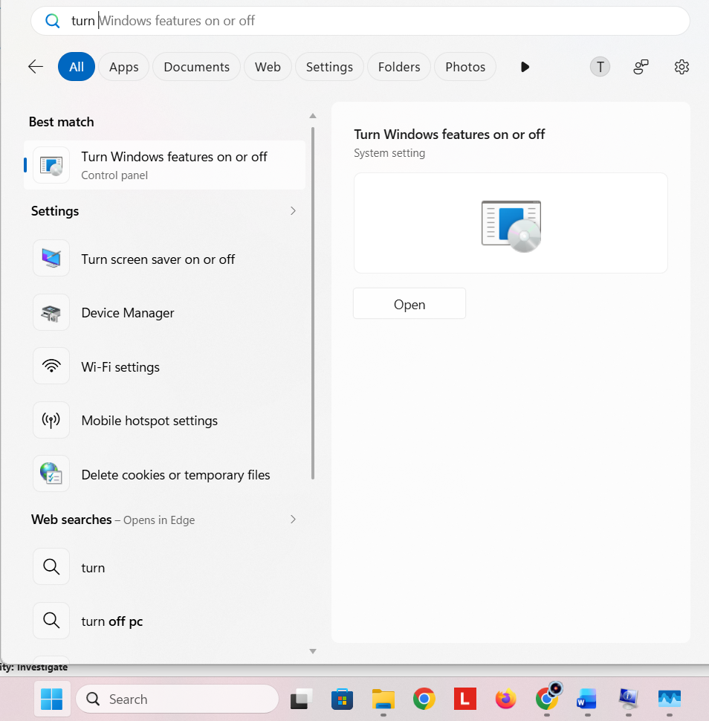
- Open the Windows Features window.
- Locate and select Hyper-V.

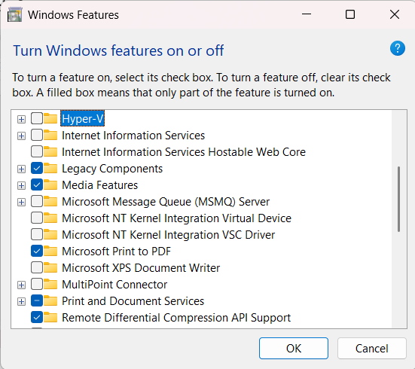
- Expand Hyper-V and ensure both options are selected:
  - Hyper-V Management Tools
  - Hyper-V Platform

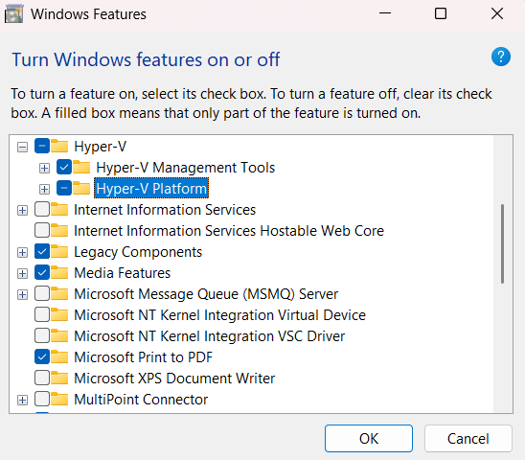
- Click OK.
- Wait for Windows to install the required components.

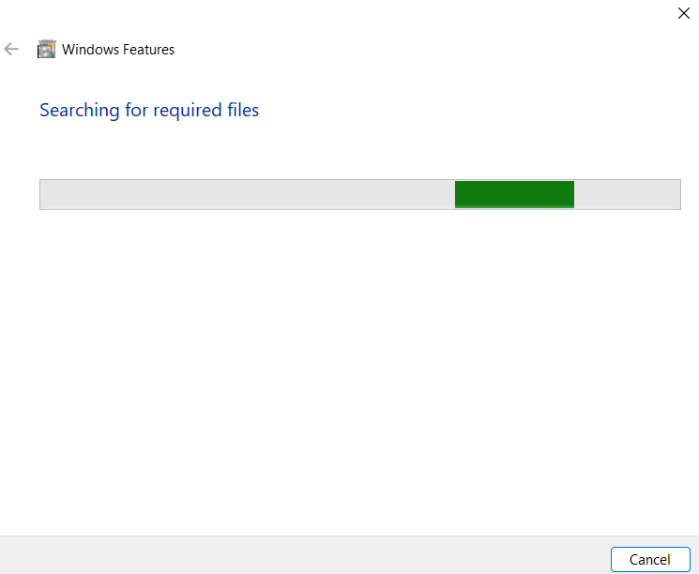
- Restart the computer when prompted.

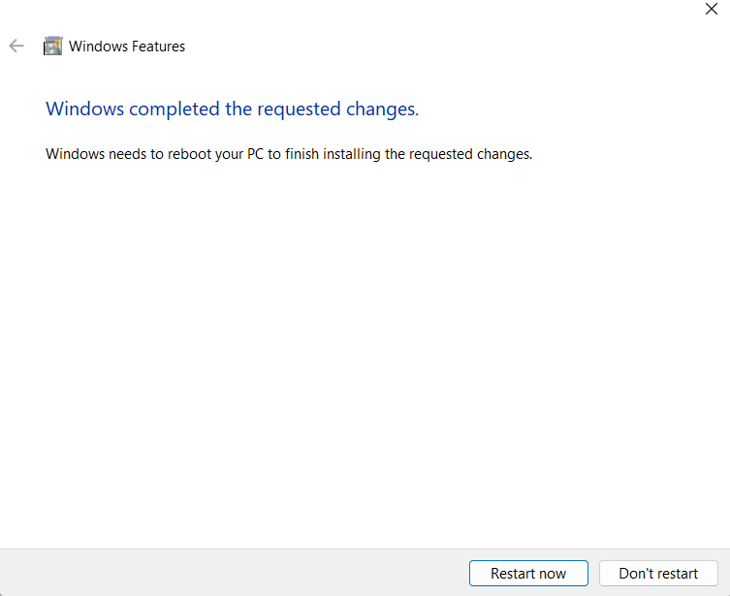
Step 3: Open Hyper-V Manager
- Open the Start menu.
- Search for Hyper-V Manager.

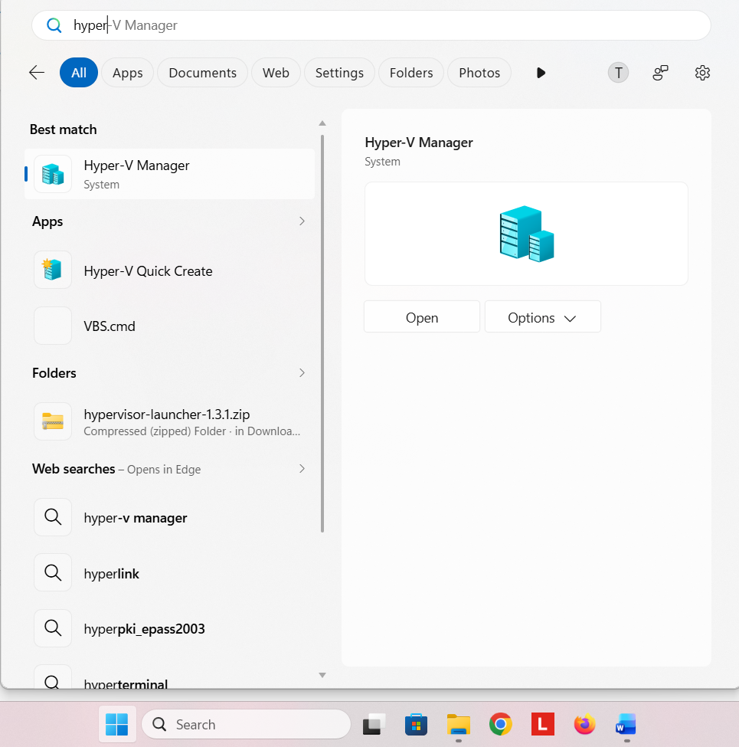
- Click to open it.
- The Hyper-V Manager window will appear.
- Select your computer name from the left panel.

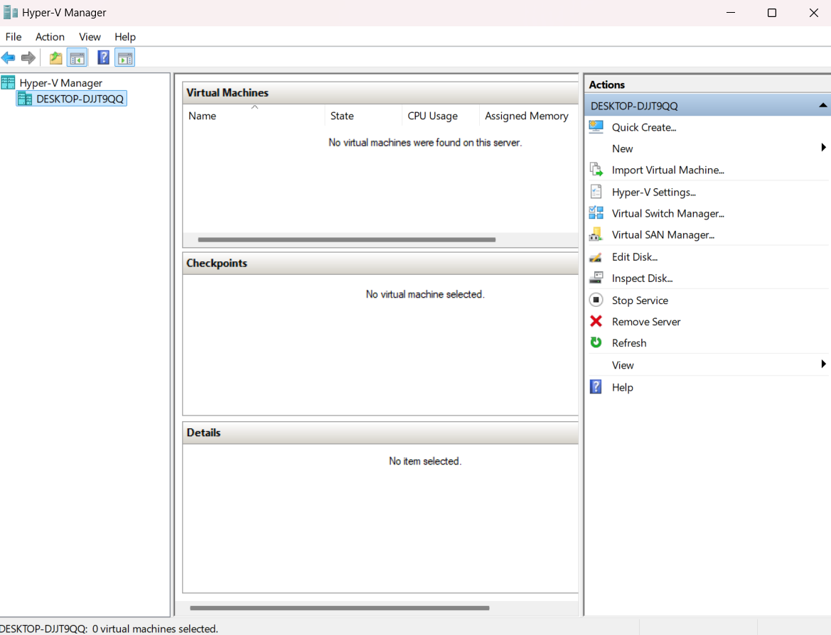
Step 4: Create a Virtual Switch
- In Hyper-V Manager, select Virtual Switch Manager from the right-side Actions panel.

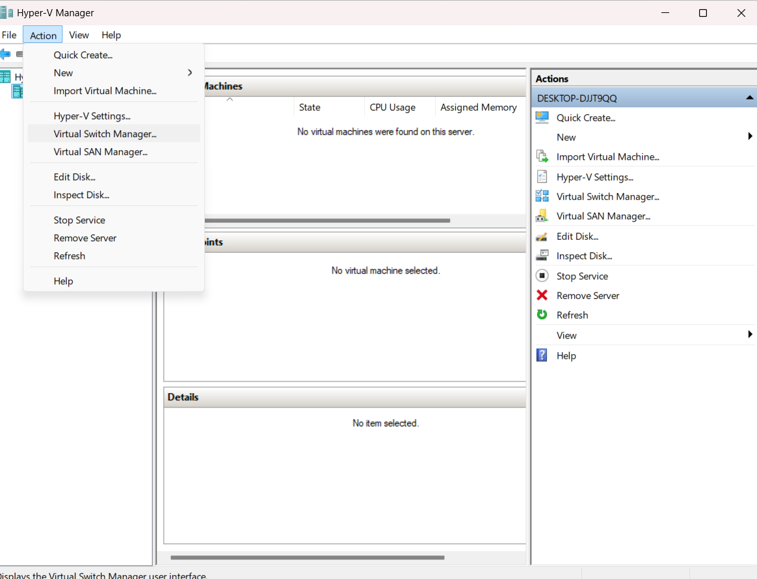
- Select External to connect the virtual machine to the physical network (if required).

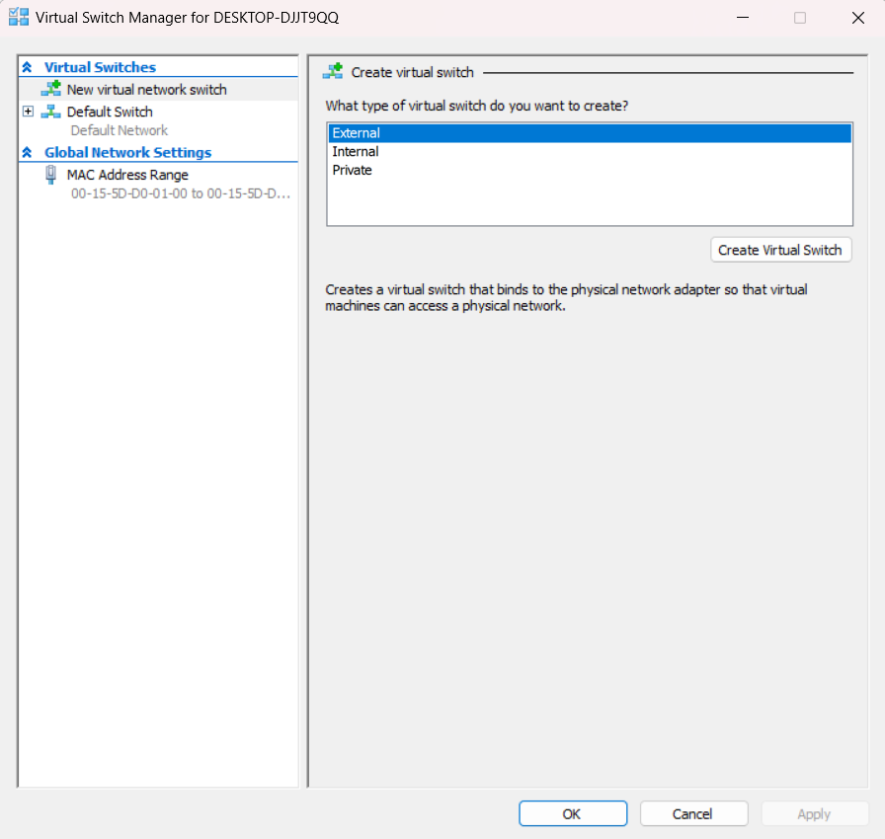
- Click Create Virtual Switch.
- Enter a suitable name, such as External Switch.
- Select the physical network adapter.

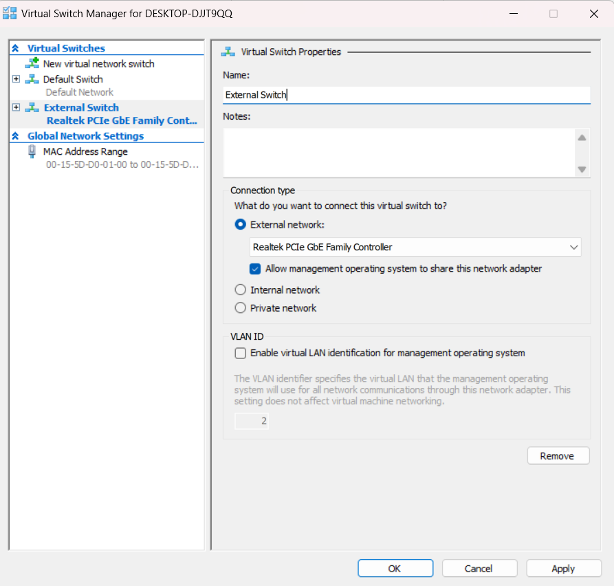
- Click Apply and then OK.

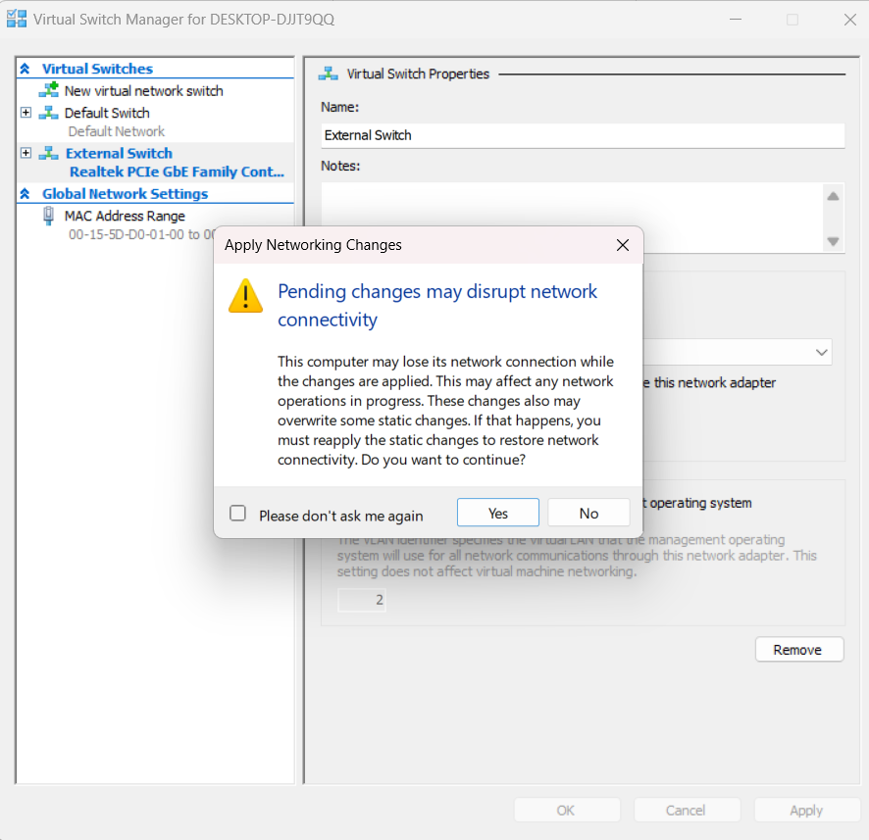
Note: Creating an external switch is optional. A Default Switch can also be used for basic internet connectivity.
Step 5: Create a New Virtual Machine
- In Hyper-V Manager, click New → Virtual Machine.
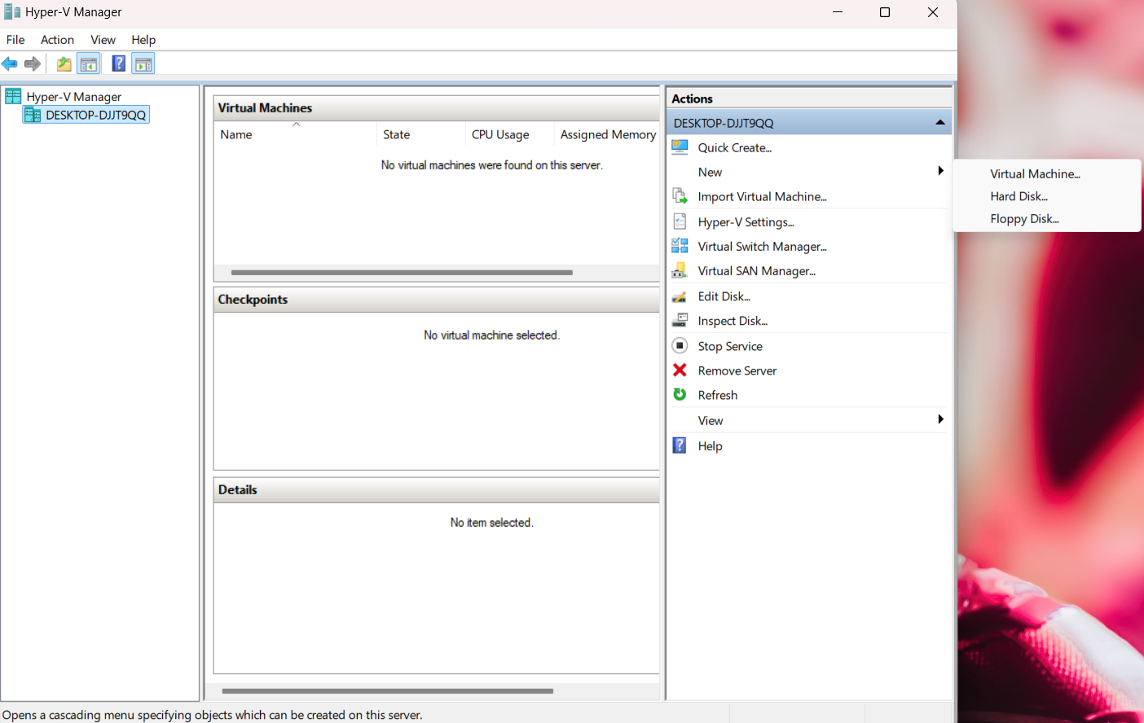
- The New Virtual Machine Wizard will open.

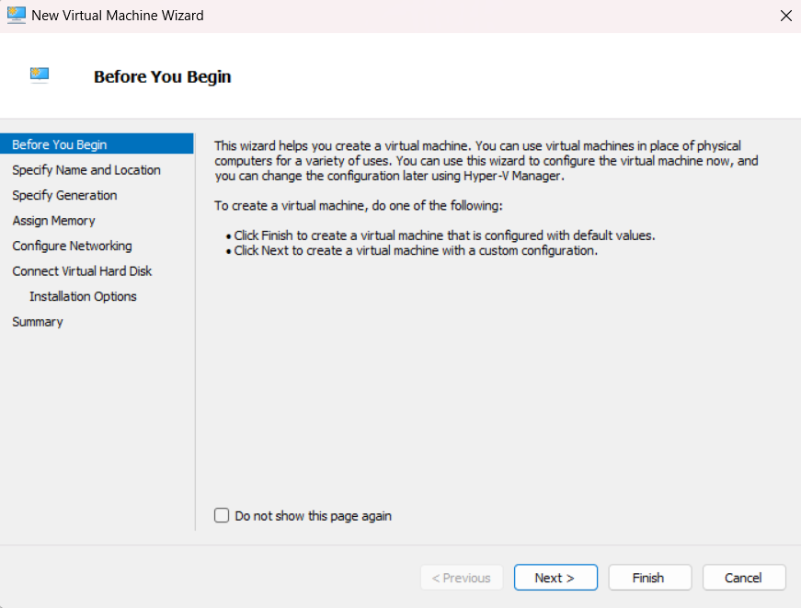
- Click Next.
- Enter the virtual machine name, for example, Windows 11 VM.

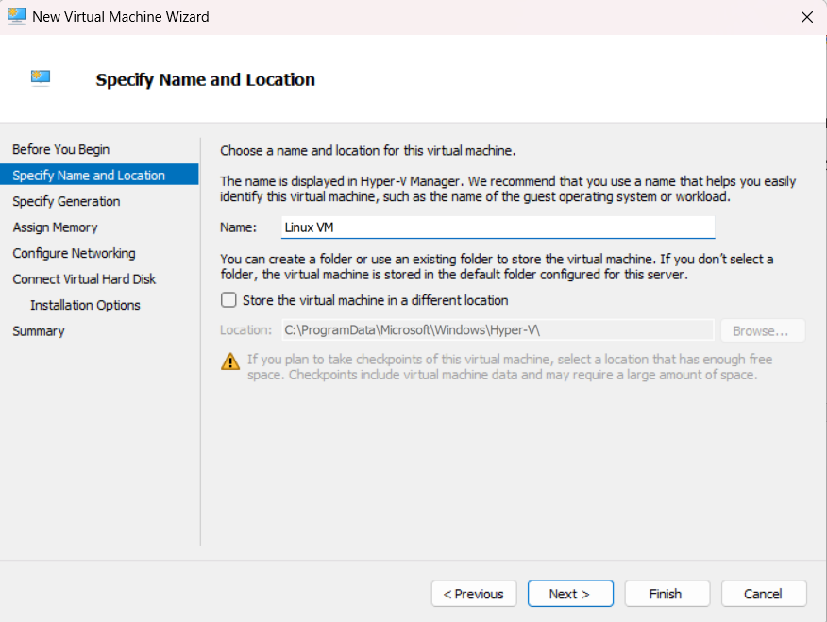
- Select a location to store the virtual machine files, if required.
- Click Next.
Step 6: Specify Generation
- Select Generation 2.
- Click Next.

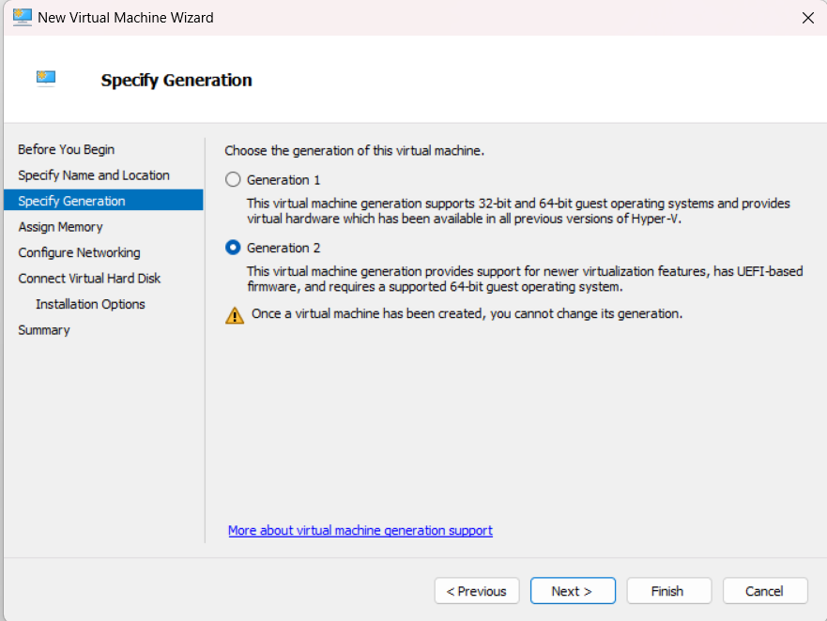
Step 7: Assign Memory
- Enter the amount of startup memory.
- For example, assign 4096 MB (4 GB), provided the host has sufficient RAM.
- Enable Dynamic Memory if required.
- Click Next.

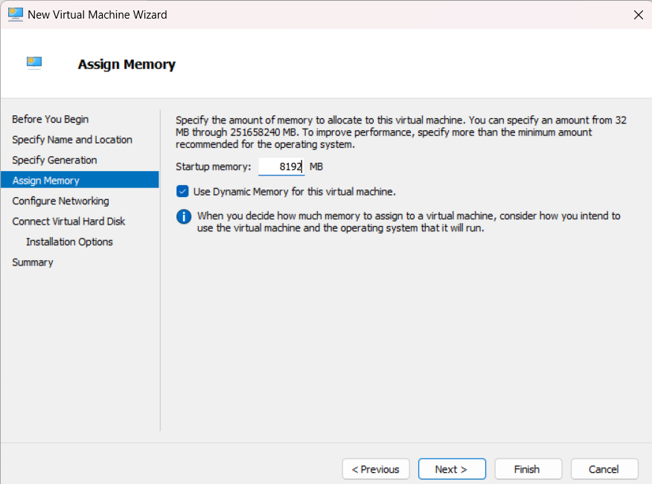
Step 8: Configure Networking
- Select the previously created virtual switch or Default Switch.
- Click Next.

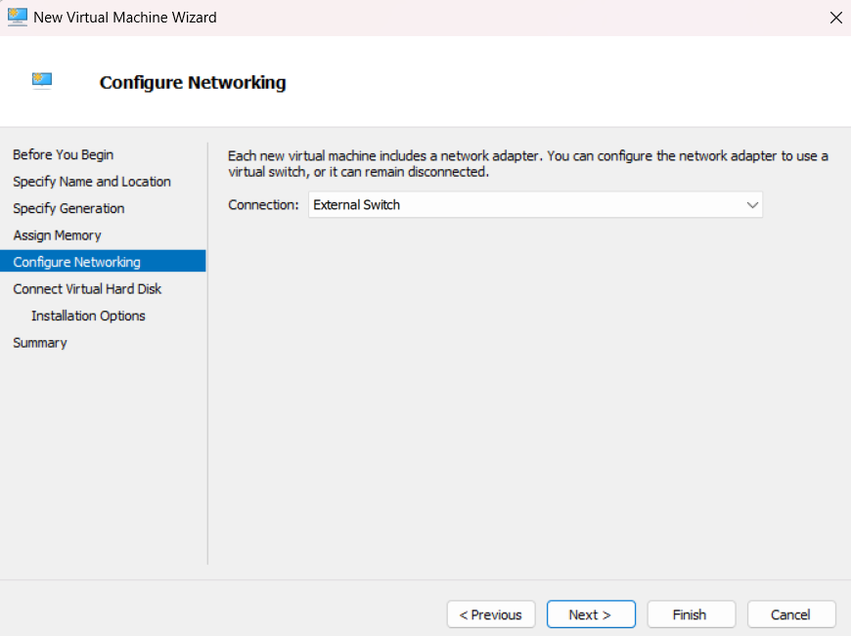
Step 9: Create Virtual Hard Disk
- Select Create a virtual hard disk.
- Enter the disk name.
- Specify the location.
- Set the disk size, for example, 64 GB.
- Click Next.

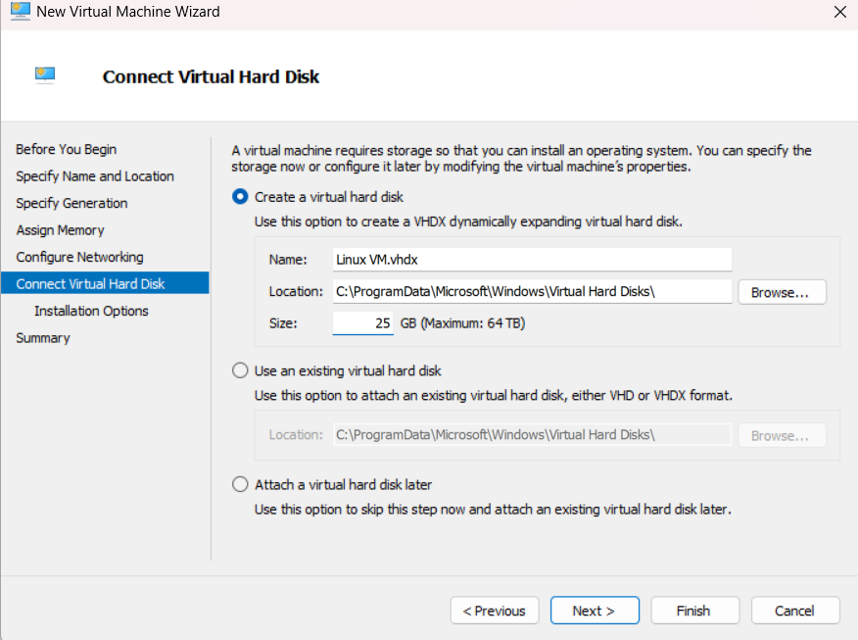
Step 10: Install Operating System
- Select Install an operating system from a bootable image file.
- Browse and select the appropriate operating system ISO file.
- Click Next.

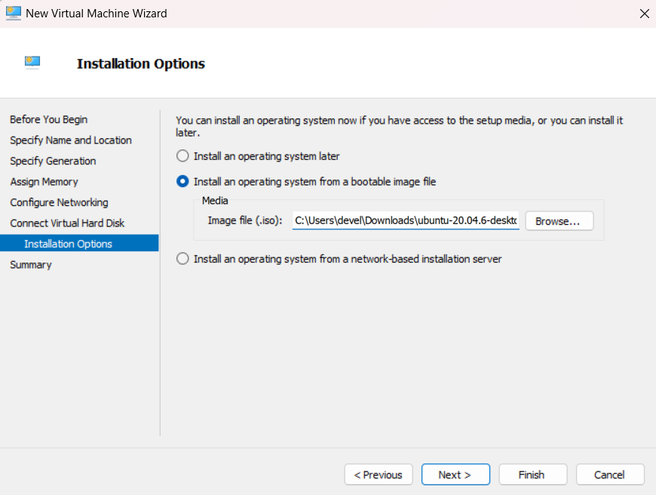
- Review the configuration.
- Click Finish.

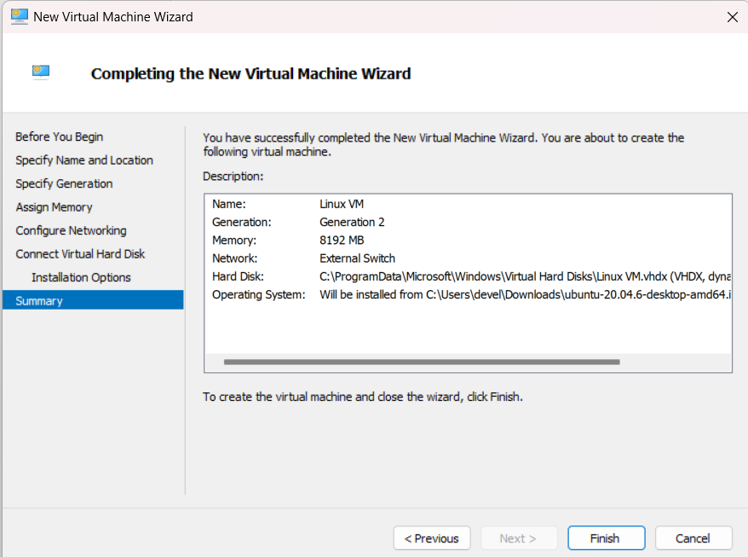
Step 11: Start the Virtual Machine
- Select the newly created virtual machine in Hyper-V Manager.

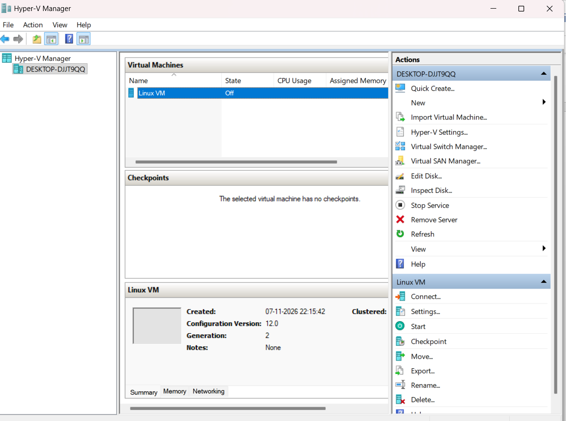
- Click Connect.

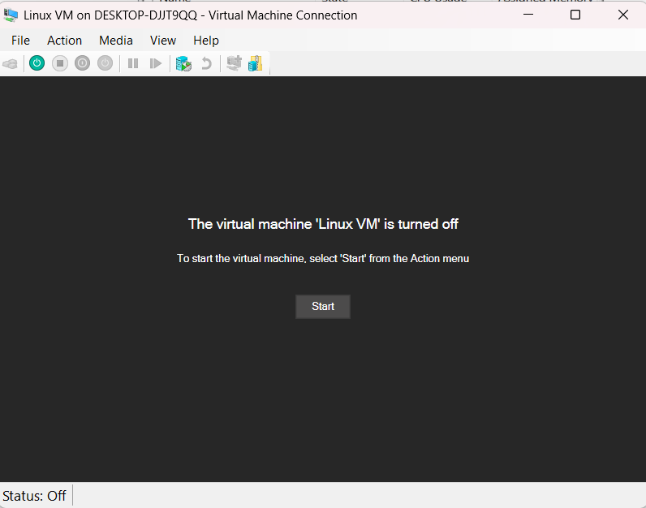
- Click Start.
- The virtual machine will boot from the selected ISO file.

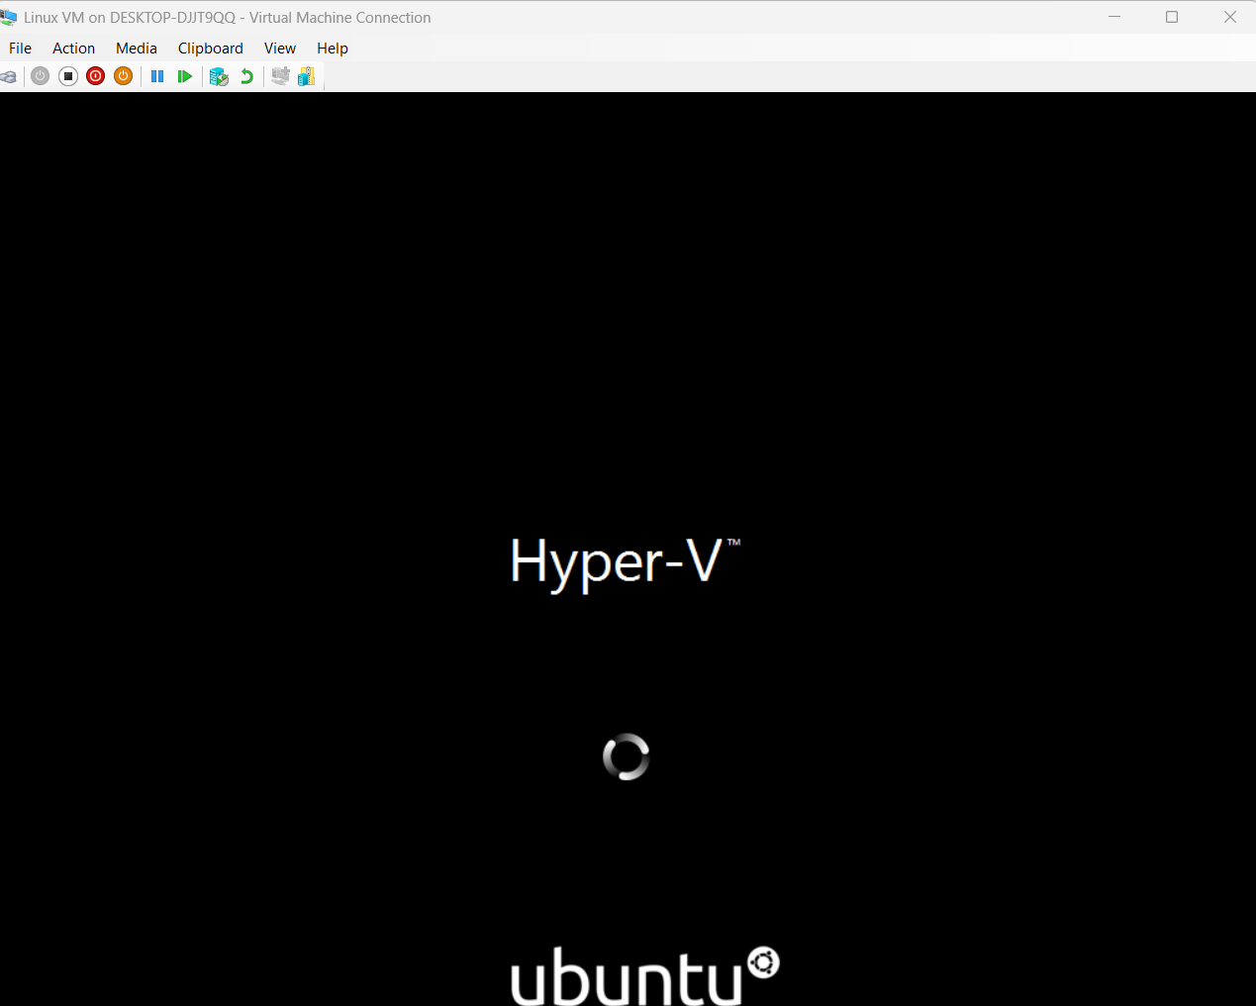
- Follow the on-screen instructions to install the guest operating system.
5. Result
Hyper-V was successfully configured on Windows 11 Pro, and a new virtual machine was created using Hyper-V Manager. The virtual machine was configured with memory, networking, and virtual storage.
6. Conclusion
Thus, we successfully learned how to enable and configure Hyper-V in Windows 11 Pro and create a virtual machine using Hyper-V Manager.

